v.3

Omeka S Archiving Workflow

A Note from the Editor

Welcome! This workflow or handbook was created to help you navigate the New Mexico Digital Heritage (NMDH) Omeka S. It was created from a Mac computer, but you should be able to easily translate the directions for a PC. Depending on your Site User role as assigned by a specific Site Administrator and your Admin User/NMDH Admin User role as assigned by the NMDH Global Administrator, you will be able to create, archive, and edit digitized items and metadata in this software. The higher your user roles, the more permissions you are granted in terms of installation, sites, pages, and content. It is highly suggested that each institution has a formal protocol so that all users create or edit information with the same standards.

Since this is a community archive, we will attempt to make your interaction with NMDH Omeka S as seamless as possible. To do this, we will start off with some background information then move on how to get started in NMDH. Next, we will go through the different categories you will be interacting with. This section of the workflow will be designed after the Navigation Bar on the left-hand side of the NMDH screen—a blue box that stays constant when you are logged on as a user. Finally, we will review some of the basics of copyright considerations and web accessibilities for other abled people.

Some areas in Omeka S will be discussed in depth while other topics will be left for you to explore on your own time through the Omeka S User Manual. This workflow is fashioned to slide you gently into the basics of archiving and site organization so that you can get your community’s memories online.

Manitos is about digital resolana—a space for you to gather your community’s knowledge and stories and share them with the comfort of others. I too hope you find some relief after acquainting yourself with Omeka S and NMDH through this workflow.

Sincerely,
Adrienne Rosenberg

Background

Helpful Resources

If you need help, contact the Manitos Project.
You can also look at the user manual for Omeka S, the system that the NMDH/Manitos Community Memory archive is built on.

Information about Omeka S Software
Omeka S is a web publication system for universities, galleries, libraries, archives, and museums. It creates a local network of independently curated exhibits sharing a collaboratively built pool of items and their metadata.

Some General Best Practices for Omeka

- Fill in all the information that you know.
- If you don’t have the information, leave the field blank. Don’t enter question marks or “Unknown” or “NA.”
- Spell out words, except for common abbreviations like Dr.
- Spell check and/or verify the spelling of the names of people and places.
- Avoid the use of all caps, as it can be difficult to read.
- Use the simplest language appropriate for your Item, Item Set, etc. Make sure it is grammatically correct.
- Use the Value Suggest plugin to help add terms from controlled vocabularies.
- Be consistent.
- Double check your work before hitting the “Save” button. Of course, you can always edit your work later.
- If you paste a link into a field that is from the NMDH site, be sure you are logged out. Otherwise you are posting from the admin side to the side, which means the public will NOT have access to that link.

Using Diacritics in Metadata Fields

If you are using a PC, you can hold down the “Alt” key and type four numbers. This will produce an accented character.

Á 0193 | á 0225
É 0201 | é 0233
Í 0205 | í 0237
Ó 0211 | ó 0243
Ú 0218 | ú 0250
 | ñ 0241
If you are using a Mac…
Á option/alt + e then shift + a | á option/alt + e then a
É option/alt + e then shift + e | é option/alt + e then e
Í option/alt + e then shift + i | í option/alt + e then i
Ó option/alt + e then shift + o | ó option/alt + e then o
Ú option/alt + e then shift + u | ú option/alt + e then u
 | ñ option/alt + n then n

Our Item Example

We will be using the following example throughout the workflow to help you understand the process and vocabulary used by Omeka S.
Pablo Martinez has a black and white 3 x 5, World War II Army headshot (still image) taken by the United States Army in Germany of his grandfather Lieutenant Orlando Martinez in 1941. Pablo brings the photograph to the Costilla, NM Manitos group hoping that they can add his grandfather’s photograph and story to the New Mexico Digital Heritage archive.

A Few Helpful Terms

Installation: An instance of Omeka S. Typically, a central IT department of an institution does the process of installing and probably also creates Sites for others. Our Installation is the New Mexico Digital Heritage- Manitos Community Memory (NMDH).

Site: Sites are the public-facing side of an Omeka-S Installation. With Sites you can create content and interpretation around a group of Items from your Installation. (Ex.- Costilla, New Mexico)

Pages: Pages form the content of your Sites. A Site can have a single Page or many Pages. You may organize your Pages however you wish. (Ex. On the Costilla site, the creator may choose to create Pages based upon different time periods of the colonial settlements. He or she may create a Page named “World War II.”)

Item: The records used to build an Omeka S Site. Items are shared and available to any Site in an Installation, unless explicitly excluded from sharing. (Ex.- The digitized army headshot still image taken in 1941 of Orlando Martinez, a WWII veteran from Costilla would be an Item.)

Item Set: An aggregation of Items. Items can belong to any number of Item Sets. Not all Items need to be put into a set. (Ex.- On the “World War II” Page in which there are Item Sets of “Life at Home in NM,” “Army Life,” and “WWII Veterans.” The creator could file the headshot of Mr. Martinez in the WWII Veterans Item Set.)

Relation: A metadata field in an Item and Item Set that is for a related resource. One can select Items or Item Sets in NMDH or an external website using the URI. (Ex.- Selecting a different Costilla, NM site Item (document) that Orlando received in 1989 honoring New Mexico veterans.)

Slug: A slug is the Page’s portion of the URL and can only contain letters, numbers, and hyphens; no other characters are allowed. Often Omeka will create a slug if you do not enter one into the field.

Admin User/NMDH Admin User: This is the role assigned to each user for the entire NMDH Installation. Your role dictates your privileges on the NMDH Installation.

Site User: This is the role assigned by the Creator of a Site to a user on a specific Site. Your role dictates your privileges on the specific Site.
Getting Started

Logging into Omeka
Log in to the NM Digital Heritage site.
http://nmdigitalheritage.org/login

Note: If you have not received a login username contact Fred Gibbs at fwgibbs@unm.edu

Admin Dashboard

Once you sign into NMDH Omeka S, you will be taken to the Admin Dashboard. From here you can either Manage Resources or Manage Sites. On the left-hand side in blue, you will see what we will call the Left-hand Navigation Bar, or Navigation Bar for short.

Left-hand Navigation Bar

Each action to archive and organize is described below in the order it appears on Navigation Bar.

The Left-hand Navigation Bar of the dashboard is divided into sections related to function and Admin User/NMDH Admin User access:

- Sites: lists and provides access to all of the Sites on the OmekaS Installation. (Computer icon is beside it. This category expands according to particular Admin User/NMDH Admin User and Site User permissions.)

- Resources: content creation and metadata management
  - Items: manage the individual digitized pieces of your Installation. (Box icon)
  - Item Sets: manage aggregated groups of Items. (Multiple boxes icon)
  - Vocabularies: manage the metadata standards for your install. (Closed book icon)
  - Resource Templates: manage predefined sets of properties (fields) to use when creating Items. (Pencil in a square icon)

- Admin: Installation-level administration
  - Users (Site User): manage users for the whole install and individual Sites. (head and shoulders person icon)

Note: Admin Users/NMDH Admin Users with more limited permissions will see only some of these navigation options.

Below is how it appears on when you are logged in as an Administrator.
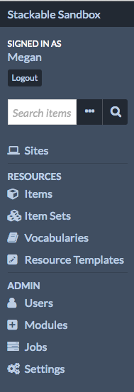
In the upper left corner of the screen is a link displaying the title of the Installation, here “Stackable Sandbox,” which will always take you back to the admin dashboard.
Directly below the Installation title is the message “Signed in as…” where your name (the username) should be the displayed. Near the username (below or to the right, depending on window width) is the button to “Logout.”

Signed in As

On the Navigation Bar you should see your name under “Signed in as…” Click on your name to see what your current status is. If you wish to edit your information, you can click “Edit User” in the righthand corner. The only tab you will really need to edit is the User Information.
A Note on NMDH Admin User Roles in Omeka S
There are six Admin User/NMDH Admin User roles in Omeka S:
- Global Admin: full Installation privileges (overrides any Site User permissions)
- Site Administrator: robust Site and content privileges
- Editor (Content Expert): full privileges for content creation
- Reviewer: robust content privileges but can only delete own content.
- Author: Create own content.
- Researcher: Search and read privileges only.

Only Global Administrators can create, edit, and delete NMDH Admin User roles and their information. Site Administrators, Editors, Reviewers, Authors, and Researchers can edit their own NMDH Admin User information but cannot change the information of other users.

To see other individuals who are users in the New Mexico Digital Heritage Installation, click on “Users” in the Navigation Bar under Admin. A list of users with emails, roles, and date they become users are listed.
Note: As discussed in the User Permissions section, each Site has a set of user permissions unique to the Site. These are known as Site Users. The Administrator of each Site is the individual who can change your role and overall access within a Site but not the whole NMDH Installation. As Administrator, be sure to enable individuals you wish to have access and management within your specific Site beyond what is assigned to the individual within the larger NMDH Installation.

Sites
Sites are the public-facing side of an Omeka S Installation. With Sites you can create content and interpretation around a group of Items from your Installation. Permission restrictions according to your NMDH Admin User role and/or the specific Site User role may apply and limit your abilities with creating/editing Sites.

Creating or Editing a Site in Omeka S
Note: This workflow will not cover Resources, Settings, or CSS Editor as a part of Creating or Editing a Site in Omeka. Please go to https://omeka.org/s/docs/user-manual/ for more information on these topics.

Creating a Site

On the Navigation Bar, you will see Sites with a computer icon. Click on this to pull up the various Sites within the NMDH Installation. You will see the Title, URL slug, and Owner of the Site. You can click on each of these Sites to view a summary page, however, you can only create or edit a Site if you are given the role of Editor or above. Only Global Admins and Site Creators can delete a Site.

To create a new Site, click on “Add New Site” in the righthand corner.

In the Admin tab, fill in the Title, URL slug, and Summary. The summary is a brief description of what the Site is about, and it will appear on your Installation's landing Page and on list of site blocks.

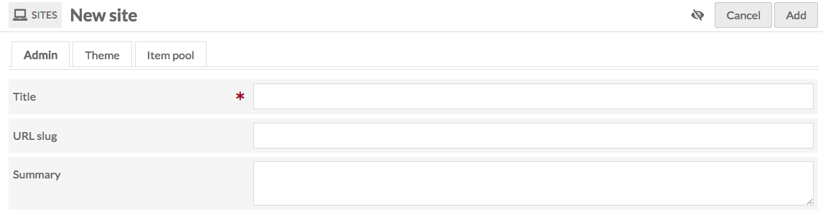

The next tab is the Theme. Choose the “Manitos” theme that Fred Gibbs has created. Do this as soon as you can. Otherwise when you view your page, it will show up as “Omeka S encountered an error.”

The final tab is the Item Pool. This workflow will not cover Item Pool, but you can find out more at https://omeka.org/s/docs/user-manual/sites/#the-item-pool-tab

Publication Settings

In the upper right-hand corner of the screen, next to the “Add” button, you can set the visibility of your Site using the “Make Public/Private” button (eye icon).
Public
Private
You will probably want to leave the Site Private until you have added some content.

Click “Add” to add your Site to the NMDH Installation.

Editing a Site

If you possess the permissions to edit a Site, there will be a pencil next to the Site name on the Sites page. Click on the pencil to edit the Site.

If you have appropriate permission, a set of new options opens on the Left-hand Navigation Bar. We will now go through each of these options.

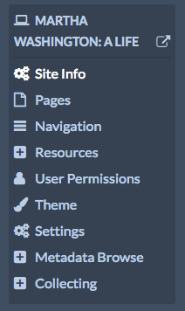

Site Info

Site Info is the Title, URL slug, and Summary you have already created in Creating a Site.

Creating, Editing, and Viewing Pages in Omeka S
Pages form the content of your Sites. A Site can have a single Page or many Pages. Permission restrictions according to your NMDH Admin User role and/or the specific Site User role may apply and limit your abilities with creating/editing Pages.
ages.

Manage the Pages for a Site from the Admin Dashboard by clicking on “Sites” on the Navigation Bar. Select the Site for which you want to manage the Pages. Then click either the title of the Site or the edit (pencil) button to edit that Site.

Then you will see the name of the sight you selected under Sites and click the “Pages” tab in the Navigation Bar. Here the Site is Jane Austen.

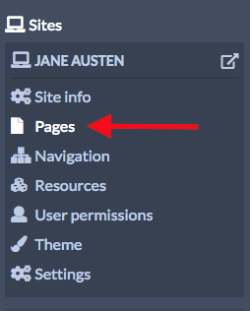
From here you can either add a new Page or edit a Page.

Note: When you create a new Site, Omeka S automatically adds a Page titled Welcome with a single HTML block. You can edit this Page or delete it (see below).

Creating Pages

From the Pages, click the “Add New Page” button on the upper right side of the window.
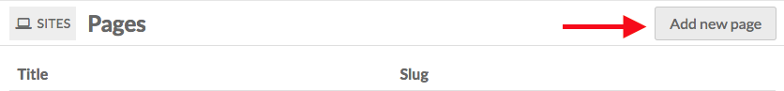
On the new Page, enter a Title. You can also enter a URL Slug. Both of these can be edited later but are required to create the Page. If you do not enter a Slug, Omeka S will create one from the page title.

In addition, there is a checkbox for "Add to Navigation." If checked, the Page will automatically appear at the main navigation level for the Site. If you do not check this box, you will have to manually add the Page to the Siavigation at a later point. It is suggested that you check it initially.

Once you have entered this information, click the “Add” button in the upper right-hand corner of the browser window. You will be automatically taken to the edit form for that Page. Text highlighted in green will say, “Page successfully created.” Here you will create the visual look of your Page using Page Blocks (HTML, Page title, Media, etc.)

Page Blocks

Pages are made up of blocks, each of which has a different form of content and will visually construct your Page. On the right-hand side of the Page is the list of blocks.

Note: For the brevity and simplicity sake, this workflow will not cover the following blocks: Browse Preview, Item Showcase, List of Sites, Table of Contents, or Item with Metadata. For more information please see Pages Management at https://omeka.org/s/docs/user-manual/sites/site_pages/

Page Title

Displays the title of the current Page. You have already named this Page in the Adding Pages step.

HTML

Clicking on the HTML creates field in which you can add formatted text and links. When you click in the box, a formatting menu will display above the text field.

Media

Creates a block with one or more pieces of media associated with Items in the Item Pool. In Media blocks, multiple attachments stack vertically.

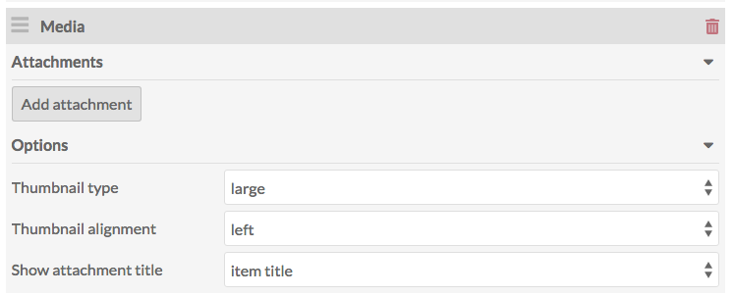
To add media, click the “Add Attachment.”

On loading, the drawer will show a list of your Items, most recent first. You can select from the first page, flip through using the forward and back arrows, or search using the search bar. This is a way to place your Item within a certain Page on your Site. You do not have to reenter all of the metadata content as it will be associated with your attachment that you choose from the drawer.

Remember: You will need to have digitized and archived an Item before you can access it here. (See Creating or Editing Item in Omeka)
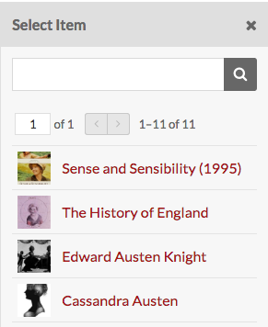

Once you’ve selected an Item, the drawer on the right-side will shift to that Item’s information. You can add a caption and select which media (if more than one) you want to use. To change the Item, click the “Change Item” button at the top of the drawer. You will be able to reselect a different Item for the media. To use the Item displayed and apply the caption, etc., click the “Apply Changes” button at the bottom of the drawer.
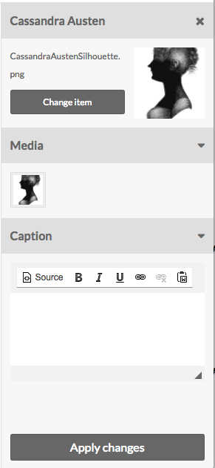
The Media block has options for the display of the media:

- Thumbnail type: choose from large, medium, and square.
- Thumbnail alignment: relative to Page. Choose from left and right.
- Show attachment title: Choose whether the media should have a caption of the Item title, file name, or no title displayed at all.

Note: If you want media to appear beside/wrap a block of text, place a media block above an HTML block and select a smaller thumbnail size. In the example below, the media has a thumbnail type of Medium, alignment Right, and attachment title of the Item Title:
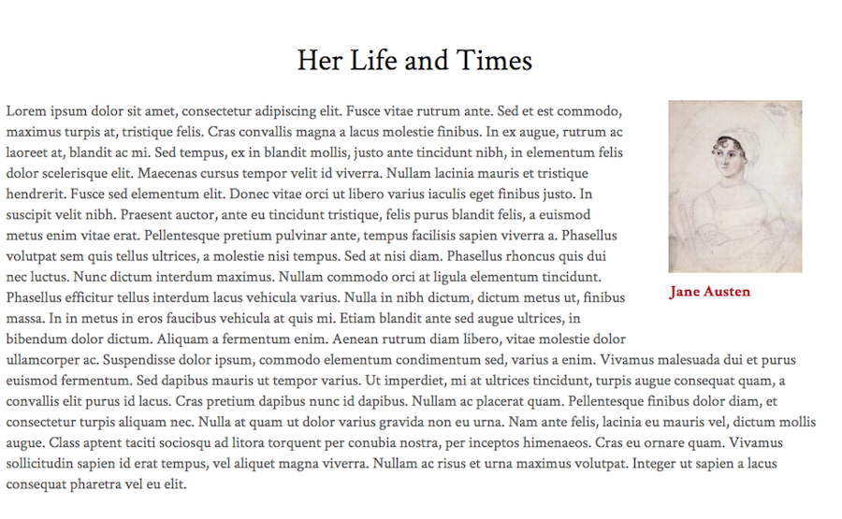

Placing a media block after an HTML block will cause the media to appear below the end of the HTML paragraphs.

Line Break

Line Break creates a transparent or opaque line break on the page to separate out sets of information. It will not intersect any of the blocks, but it can be used multiple times. Select whether the line is transparent or opaque from the dropdown.
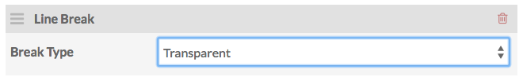
HTML blocks wrap around Media blocks and at times you may want to clear the page. You might also want to create a visual break on the page.

More…

Change the order of your blocks by clicking on the three horizontal lines on the upper left corner of the block and then dragging and dropping it to the desired location.

If you wish to delete any of the blocks, you can click the trashcan button at the right-hand side of the block. If you deleted in error, you can click the reverse arrow button that appears after you delete the block to undo the deletion.

To save the Page, click “Save.” Then you can click “View” in order to preview what the public sees. If you are clicking “View” but do not see your latest edits, remember to click “Save” first then “View.”

To delete the Page, go to the “Delete” button. A drawer will open on the right side of the Page asking you to confirm that you wish to delete the Page, with the name of the Page displayed under the confirm button. To proceed, click the red “Confirm Delete” button. Otherwise, click the “X” in the upper right corner of the drawer to cancel.

Editing Pages

After clicking the “Pages” in the Navigation Bar, select the Page you wish to edit by clicking the name of the Page or the edit button (pencil). From here you can edit the Page as described in more detail in the Adding Pages section. Remember to click “Save.”

Viewing Pages

If you are on the admin side and click "View" in the upper right-hand corner of a Page, Omeka will create a new tab that will take you to the public view for that Page. Again, you will have to “Save” your work before you can see it through the view option.

If you are not able to directly edit the Site from the newly opened “View” tab, you can go back to your “Edit” tab to make edits.

Navigation

Use the Navigation tab on the Navigation Bar to set the order of Pages. For more about Navigation go to https://omeka.org/s/docs/user-manual/sites/site_navigation/

Don’t forget to save all of your actions by clicking “Save” in the upper right-hand corner.

Resources

This workflow will not be discussing the Resources. For more information, please go to https://omeka.org/s/docs/user-manual/sites/site_resources/

Site User
- Viewer: user can see the Site’s backend but cannot edit.
- Editor: user can access and edit the Site’s backend.
- Admin: user has full administrative privileges for the Site, including adding users and deleting the Site.

Permissions

When clicking on “User Permissions” in the Navigation Bar, you will see the Site’s User and Role. This is Site specific user roles (or Site User roles) versus NMDH Admin User roles. Roles include Viewer, Editor, and Admin of the Site

You can add or revoke privileges for specific Site User permissions by going back to the User Permissions tab and selecting or deselecting the boxes and clicking “Save.” Users can be deleted from the Site by clicking the trash can icon on their row.

Theme

The next tab is the Theme. Select from the given Themes. Each Theme appears as a button with a screenshot of the Theme, the Theme name, and a link to its creator. The “CURRENT THEME” will be displayed at the top. When you select a Theme, click on the box and a grey checkmark will appear.

There is a “Manitos” theme that was created by Fred Gibbs. Use this one for your Site to keep visual continuity in the Installation. Do not click “Edit Theme Settings.” These have been set by Fred Gibbs.

Click the “Save” button at the right-hand corner after you have selected the “Manitos” theme.

Resources

Creating or Editing an Item in Omeka
Omeka defines an Item as “The records used to build an Omeka S Site. Items are shared and available to any Site in an Installation, unless explicitly excluded from sharing.” In short, an Item is the digitized archival object that you are entering into the Omeka site such as a photograph, a legal document, a map, audio recordings, etc. Permission restrictions according to your NMDH Admin User role and/or the specific Site User role may apply and limit your abilities with creating/editing Items.
Creating an Item

Click “Items” in the Navigation Bar, under Resources.

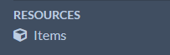

Here you will see all the Items that have been entered into the collective NMDH Installation. Listed are the Item, Class, Owner, and Created, or date it was created.

You can click on the Item to view its Metadata and Linked Resources as well as edit the Item.

To create an Item, go to the Items page by clicking “Item” in the Left-hand Navigation Bar and then click “Add New Item” at the upper right corner.

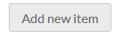

Click on the “Values” tab. This is where you will enter your metadata on your Item.
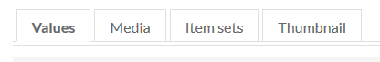

You can remove a field by clicking on the red trash can to the right of it or make it private by clicking on the eye icon.

You can add an additional instance of the field by clicking on the “Add Value” button(s) below the field.

Note: Different resource templates may display additional fields, but we will be going through the “Still Image” template using our World War II still image example.

Note: All fields are searchable so consider this when entering your information.

Note: Use the Item Intake Form found in the Organizing Workflow.

Resource Template

Select a Resource Template from the dropdown menu– this will help connect your Item to similar Items in the archive.

Note: As of December 1, 2019, the only templates that can be used are “Base Resource” (do not use) and “Still Image.” More templates will be created in the future. After the other templates are created, you can switch the resource template to the appropriate one and not lose the metadata associated with the Item. But for now, we will use “Still Image” for this workflow.

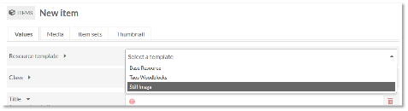

Once you select a template, more text fields will appear. You should include at least a Title and a Creator (if you know it), but any other fields can be left blank if you don’t know what information to enter. Do not enter “?,” “NA,” “Unknown,” etc. into the field. Instead, leave it blank.

Title

The title of the Item. If the Item’s creator gave it a title, enter that title. If not, you can create a brief descriptive title. You will have a chance to enter more information about the Item in the Description, so keep the title brief and think about the other Items you will be entering that are associated with it. This is part of your Organizing Workflow.

(For example, the title could be “Orlando Martinez, Lieutenant United States Army; World War II.”)
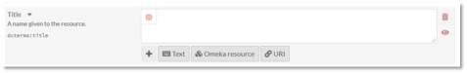
Creator

The name of the person who made the Item. This might be a person, several people, or an organization. If you don’t know, you can leave this field blank.

(For example, the photographer who took the Orlando Martinez, WWII Veteran. In this case it would be “The United States Army.”)

Subject

The best practice for this field is to enter Library of Congress Subject Headings related to the Item. This can be complicated, but the Value Suggest plugin can make suggestions to help you. To do this, start to type in a word then scroll through the menu that appears with the word prompt to select what best fits your Item. You can also search for appropriate headings in the Library of Congress Subject Authorities.

Click the “Add Value” button if you wish to connect more subjects to this field.
(For example, one subject “World War, 1939-1945” is a Value Suggest. Below a link appears that will hyperlink the subject words on the public side.)

Description

Here is your chance to describe the Item in detail. You can tell the story behind the Item, if you know it. Why is the Item important? You can describe what is in the photograph, for example, as well as the history of it. Include words written on the back of the photo if there are any. The Getty Art and Architecture Thesaurus can help with writing descriptions for photographs and artwork. Hitting return will add a paragraph break.

Remember: How does the Item relate to Manitos Community Memory project?

(For example, Orlando Martinez was in the United States Army from 1934-1948 and stationed in Germany. He was a lieutenant from Costilla, New Mexico and son of Armando and Lucita Martinez…..)

Type

The best practice for this field is to enter one of the following types: Text, Still Image, Moving Image, Sound, Physical Object, or Dataset.

(For example, “Still Image.”)

Relation

The relation is an option if you would like to connect your Item with any other Items, Item Sets, or URIs outside of the NMDH installment.

(For example, Orlando Martinez’s headshot page could be linked with another Item that is a digitized award (document) that he received in 1989 honoring veterans of New Mexico.)

If you wish to add more value fields, you can click on the “Text” box below the field box. You can also access “Omeka Resources” and “URI”s to the format. However, these are extra abilities that are beyond the scope of this workflow.

Date Created

The date the original Item was created, if you know it. For example, “05/10/1965.” If you only have a general idea of when the Item was created, or if it was created over time, you can enter an approximate period of time, like “1940-1945.” If you don’t know, leave the date field blank.

(For example, Orlando’s photo was taken in 1941. So, you would enter “1941”.)
If you wish to add more value fields, you can click on the “Text” box below the field box. You can also access and “Omeka Resources” and “URI”s to the format. However, these are extra abilities that are beyond the scope of this workflow.

Date Modified

The date the Item was changed; for example, a document that was worked on by more than one person might have a Date Modified as well as a Date Created.

If you wish to add more value fields, you can click on the “Text” box below the field box. You can also access and “Omeka Resources” and “URI”s to the format. However, these are extra abilities that are beyond the scope of this workflow.

Rights

The Rights Statements Quick Reference can help you select a rights statement for your Item. RightsStatements.org provides more information to help you choose a rights statement. If you are the creator or owner, you can consider using a Creative Commons license depending on how you want others to use your Item. Strongly consider creating a consistent rights statement for your organization.

Format

The file format, physical medium, or dimensions of the Item. For example, the format of a drawing might be “Pen and ink, 3 x 5 inches.” The format of a sound or video file might be “40 minutes.” For a digital resource, the format might be “PDF,” “JPG,” or “PNG.”
If you wish to add more value fields, you can click on the “Text” box below the field box. You can also access and “Omeka Resources” and “URI”s to the format. However, these are extra abilities that are beyond the scope of this workflow.

(For example, Orlando’s photograph would be “3x5.”)

Language

The language that the Item is in. However, if the Item does not contain any text, leave this field blank.

Publisher

The organization or person that published the Item.

Coverage

In this example, this field indicates geographical locations related to the Item. It is best to use the Getty Thesaurus of Geographic Names to find the standard format for a place name, if possible.

(For example, enter “Germany.”)

Contributor

This could be an editor or translator, for a book or journal; for a photograph, it might be the photographer’s studio. This field is sometimes used to indicate the person who donated the Item to a museum or archive.

(For example, Orlando’s great grandson named Pablo Martinez brought the photograph to Manitos to be archived. So, it would be “Pablo Martinez.”)

Media

After filling in the metadata fields, click the “Media” tab near the top of the Item, to attach your digitized file(s).

Using the side bar at the right, you can then upload a file from your computer or device or link to a file that is already on the internet.
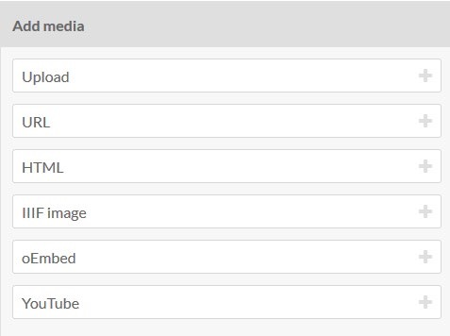
When uploading a file from your computer, click on the “Upload” button. Then give the file a title. Then click the “Choose File” button to find the Item within your computer. It may take a few moments for the file to be uploaded onto Omeka. When it is uploaded, the file should appear next to the “Choose File” button. You can only upload one file at a time per Item. The maximum upload size is 150 MB.

You can click on the other options at the right-side bar including URL, HTML, etc. and a section will be added on to the Media page for the Item.

You can then place your Item within an Item Set by clicking the “Item Sets” tab.
On the right-hand panel, you will be directed to click on an existing Item Set to add. (This may vary according to access.) This is not necessary unless you want to have your Item grouped into an existing Item Set. (See Creating an Item Set.)

The Thumbnail tab when clicked will say, “Omeka S automatically selects a thumbnail from among attached media for a resource. You may use an image of your choice instead by choosing an asset here.” However, you can also select an asset by clicking “Select.” A drawer on the right-hand side will pop open and give you a selection of thumbnails. However, it is advisable to allow Omeka S to associate the media uploaded with the thumbnail.

When your metadata is complete and you have attached your file(s), click “Add” at the top right of the screen to add your Item.
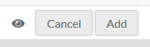

(If you decide not to add your Item, click “Cancel.”)

If your Item is added correctly, you will see a confirmation message. You will be able to view the Metadata tab and the Linked Resources tab along with the Item on the right-hand panel.

You will also have the option to edit the Item by clicking “Edit Item.”
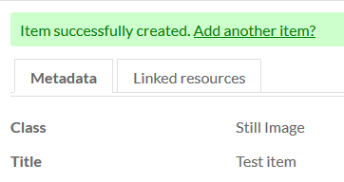
Editing an Item

If you’d like to edit your Item, you can click “Items” in the Navigation Bar, and then click on the name of your Item in the list. Then click “Edit Item” at the top right. Or you can click on the pencil next to the Item. You can then make changes or additions to your metadata or files. (See Creating Item for more detailed information.)

If you wish to delete an Item, click the trash can icon next the Item.

* Please be sure that the Item you wish to edit is in fact your Item. Otherwise you may be editing or deleting another person’s Item.
Creating or Editing an Item Set in Omeka S
Omeka defines an Item Set as an aggregation of Items. Items can belong to any number of Item Sets. In other words, an Item Set is like a categorization of Items that can be grouped together. For example, on the “Costilla, New Mexico” Site on the “WWII” Page, several individual headshots of WWII veterans can be grouped under an Item Set named “WW II Veterans.” Permission restrictions according to your NMDH Admin User role may apply and limit your abilities with creating/editing Item Sets.

Creating an Item Set

Click “Item Sets” in the Navigation Bar.

On the Item Sets page, you will see all the Item Sets that have been entered into the collective Manitos project. You will see the Title, Class, Owner, and Created—the date created.

You can click on the Item to view its Metadata and Linked Resources.

To create a new Item Set, click on “Add New Item Set” in the right-hand corner of the Item Sets page.

Here you will see two tabs, Values and Thumbnail. First fill in the Values.

Start by selecting a Resource Template. For the purpose of this workflow, again we will be using the “Still Image” template. After selecting this from the dropdown menu, you will be able to fill in the various fields as described in the Creating an Item section. Fill in the Title. Then, only fill in what you find is necessary for the Item Set. Remember: This is not your Item; this is the Item Set so the information may vary from the different Items within the set and change over time as you upload more so be general and broad.

Then go to the Thumbnail tab. You will see text that states, “Omeka S automatically selects a thumbnail from among attached media for a resource. You may use an image of your choice instead by choosing an asset here.” You can either allow Omeka S to select for you or you can select or create your own by clicking “Select.” A drawer will pop out named Upload New Asset where you can either select a Thumbnail/ New Asset or choose a thumbnail from your computer by clicking “Choose File.” From here you will be direct to choose a file from your computer that will represent your Item Set. When the thumbnail is uploaded, you will see its name beside the “Choose File” button. Click “Upload.” The thumbnail may take a moment, but you will see it appear below.

Once you have selected a thumbnail and completed the values, click “Save.” Green text will appear telling you that you have successfully created an Item Set.

Remember: Although the Thumbnail will only be a small, visual representation of your Item Set, follow the archival protocol of TIFF images at the highest dpi you can achieve.

Editing an Item Set

To edit an Item Set, click on “Item Sets” in the Navigation Bar. Click on the pencil beside the title of the Item Set you wish to edit. Or click on the “Title” and then click on the “Edit Item Set” button in the upper right-hand corner.

Note: Please be sure to edit the Item Set you were intending to. Otherwise, you could edit another users’ Item Set.

ADMIN

Users

To see other individuals who are Users in the New Mexico Digital Heritage Installation, click on “Users” in the Navigation Bar under “Admin.” These are referred to as NMDH Admin Users to differentiate from the specific Site Users. A list of Users with Emails, Roles, and Date they become users are listed. Permissions are listed in Signed in As.

Copyright Considerations

What is copyright for?

“The purpose of copyright law is to increase human knowledge, specifically by stimulating creation of as many works of authorship as possible to benefit the public.”
~Nancy Sims, Copyright Program Librarian, University of Minnesota
“Copyright Basics” from the United States Copyright Office

If you are the copyright owner, what do you own?

The right to reproduce, distribute, perform or display the work, and to create derivative works.

If you are not the owner, what can you do?

Investigate whether the Item is in the public domain. Some examples are government documents, works published in 1923 and before in the United States (with some exceptions).

Obtain permission from the owner to use or display the work. Creative Commons licenses and open access publishing make Items available with fewer restrictions than copyright.

In some cases, you can use Items under the doctrine of fair use. Four areas to consider when thinking about the use you intend:

o Purpose and character: Commercial uses are less likely to be considered fair use than nonprofit, educational, or criticism/commentary uses

o Nature of the work: Use of published works more likely to be fair versus unpublished works. Use of factual works more likely to be fair versus creative works.

o Portion used: Consider not just the amount, but how integral the portion is to the work

o Market effect of use: Will your use reduce sales, royalties etc. to the copyright owner?

This series from the University of Wisconsin-Madison will help you learn more about copyright.

Web Accessibility

Most of this is out of our control.

Included in Omeka S themes:

Landmarks for tabbing through page content Semantic markup

What we can do:
o Write clearly
o Use descriptive links
o Include captions or a transcript for audio and video
o Make sure captions are accurate
o Include alt text for images on Pages

Web Accessibility Resources

Usability.gov has lots of tools for improving overall user experience.

WebAIM provides training to individuals and organizations to improve accessibility of web content for people with disabilities. Their Web Accessibility Evaluation Tool (WAVE) helps you check websites for accessibility issues.

National Center on Disability and Access to Education addresses technology and disability in education policies and practices. See their fact sheet on Creating Accessible Electronic Content.

Oral History Metadata Synchronizer connects textual searches of a transcript or index to the corresponding moments in the online audio and video sources.
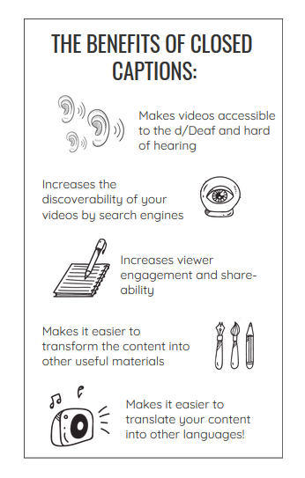
Image: 3PlayMedia, “5 Oral Histories Doing Captioning Right”

